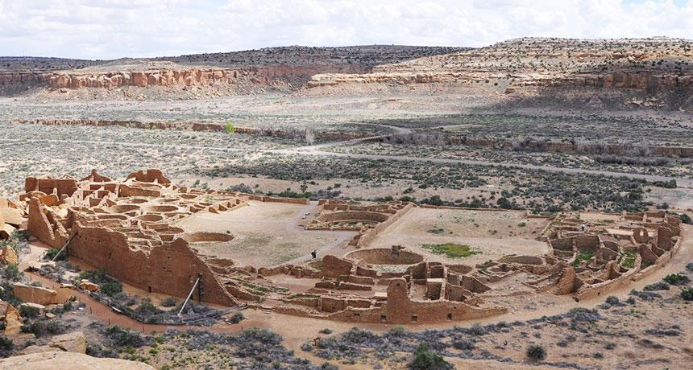
WRITING YOUR OWN COMMENT LETTER
A Set of Questions to Help You Get Started

If you choose to write your own comment letter in your own way, the questions below are here to help you think through what to say. You do not need to answer all of them. Pick the ones that matter most to you. Write what is true for you.
A few practical things first:
Address your letter to:
Field Manager, Bureau of Land Management
Farmington Field Office,
6251 College Boulevard, Suite A,
Farmington, New Mexico 87402.

Include the subject line: Public Comment on Draft Environmental Assessment — Reconsideration of Public Land Order No. 7923.
Include your name, your Pueblo affiliation if you wish, and the date. Sign your letter.
How to Submit Your Comments:
- On the federal eplanning website, when the comment portal is open: https://eplanning.blm.gov/Project-Home/?id=D949F582-402D-F111-8341-001DD804183B;
- In person: Your Pueblo Governor's office per your governor’s instructions, and partner organizations who may host community commenting sessions during the comment period. Watch for announcements from your Pueblo, APCG or one of the trusted partners described in the Pueblo Public Comment Toolkit.
IMPORTANT: DO NOT SUBMIT YOUR COMMENT UNTIL THE 14-DAY COMMENT PERIOD IS OPEN. ANNOUNCEMENTS, FLYERS, AND NOTICES WILL BE CIRCULATED FOR WHEN THE PERIOD IS OPEN.
Questions to help you write:
WHO YOU ARE AND YOUR CONNECTION TO THIS LAND
- Who are you, and what is your connection to the Greater Chaco Landscape? Are you a member of a Pueblo community? Do your ancestors come from this region? Has your family traveled to or maintained relationships with this land over generations?
- What did you learn growing up about Chaco and the surrounding landscape? Who taught you about it? What stories, teachings, or traditions of your community speak of this place?
- Have you visited places in this landscape yourself? What was that like? What do you carry with you from those visits?
WHAT THIS LANDSCAPE MEANS
- Why does this landscape matter to you? Try to put it in your own words, even if it is hard.
- What does it mean to you that this is described as a "living cultural landscape" rather than just a set of archaeological sites? Does that match how your community understands this place?
- Are there ways your community still uses, visits, or honors this landscape today?
WHAT YOU KNOW ABOUT THE LAND ITSELF
- What do you know about the water in this region? Springs, washes, seeps, water sources your family has known? Have any of them changed?
- What do you know about the plants, foods, and medicines that come from this region? Are there things your family or community gathers, or used to gather, here? Have those gathering places changed?
- What do you know about the animals, birds, or wildlife in this area, especially those with cultural or subsistence significance to your community? Have they changed?
CHANGES YOU HAVE SEEN OVER TIME
- What do you remember this region looking, feeling, or sounding like when you were younger?
- What has changed? Have you noticed differences in the night sky, the air, the smell of the land, the sounds, the traffic, the plants, the water, the animals?
- Have your elders described changes they have seen during their lifetimes? Has any of that been passed down to you?
CONCERNS ABOUT WHAT MORE DEVELOPMENT WOULD DO
- What worries you about the possibility of new oil, gas, or mineral development in this landscape around Chaco Canyon?
- What do you think would be lost if this protection is removed or narrowed? For you? For your children and grandchildren?
- Are there impacts you are concerned about that you do not think the federal government has fully considered, for example: to water, to air, to community health, to cultural places, to wildlife, to traditional life?

ABOUT THE PROCESS ITSELF
- The protections in Public Land Order No. 7923 took years of work, consultation, and federal analysis to put in place. The federal government is now reconsidering them on a much shorter timeline. Does that match how serious this decision is? Why or why not?
- Did you have enough time to read, think about, and respond to this proposal? Were there barriers that made it harder for you or your community to participate?
- Do you feel that the federal government has listened to Pueblo voices in this process? Why or why not?
WHAT YOU WANT TO HAPPEN
- What do you want the Bureau of Land Management to do?
- Do you support keeping Public Land Order No. 7923 (10-mile buffer) in place?
- What is the most important reason to keep Public Land Order No. 7923, in your own words?
CLOSING YOUR LETTER
- Why are you taking the time to write this comment? What do you want the people reading it to understand?
- What do you want to say to the Bureau of Land Management about your community's responsibility to this land, and the federal government's responsibility too?
- Is there a final message you want to leave them with?

